How to enroll in classes with
1. Go to www.flvs.net then click enroll.
9. Add your information under Student Information page
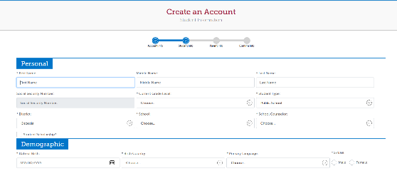
2. Select County Virtual School.
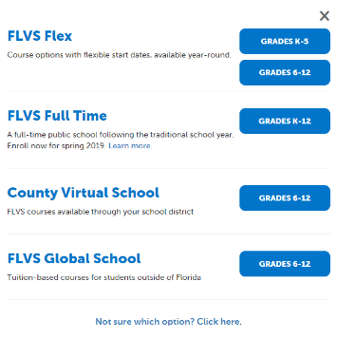

3. Click Enroll, under the circular photo 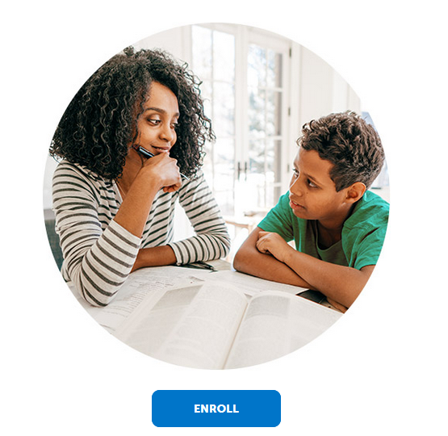

4. Choose your County & Student Type (public school)
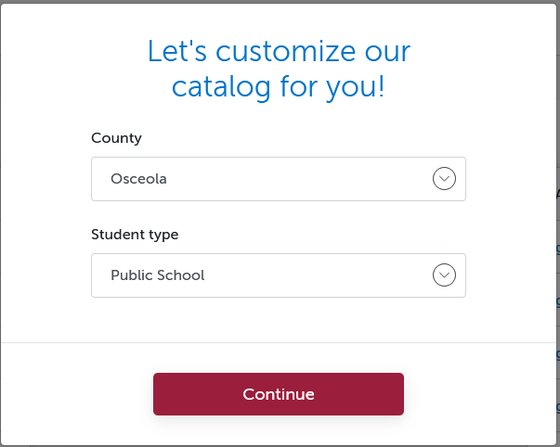
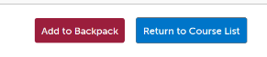
5. Choose your class, click

6. Click continue, or add more classes
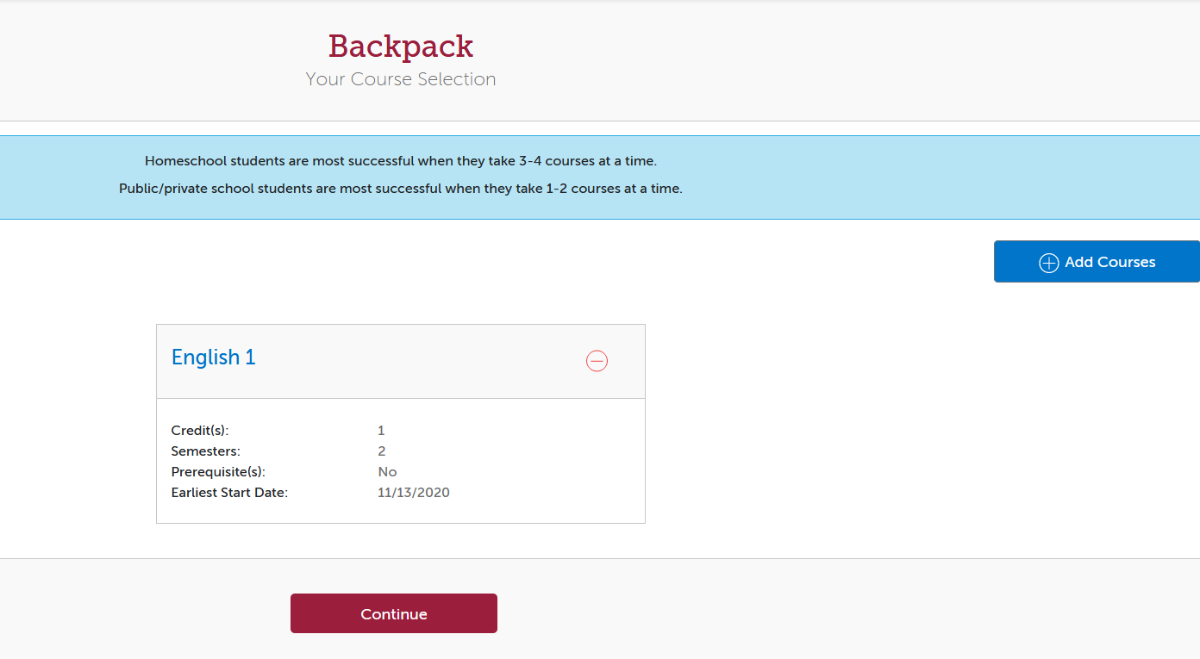

7. Click
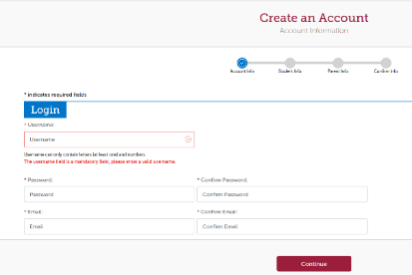
8. Enter information in all fields marked *

10. Add your parent’s information
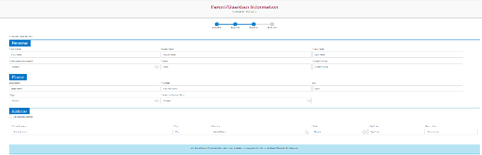

11. Confirm information
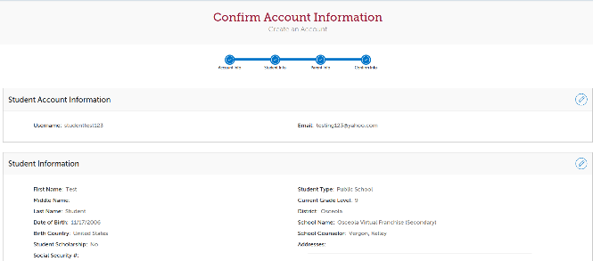

12. Click continue at bottom, take survey, agree to commitments, and media release.
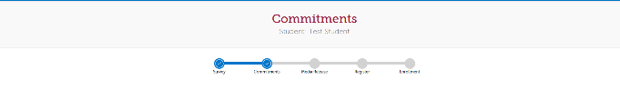

13. Choose Semester (1,2,orAll), preferred start date, and OVSS as your preferred school:
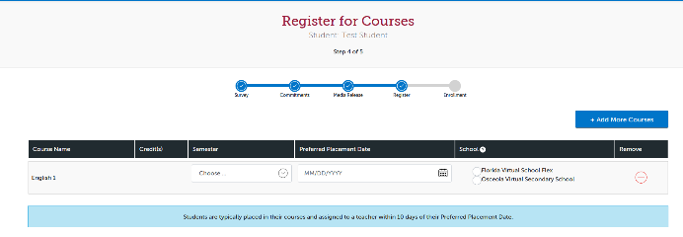

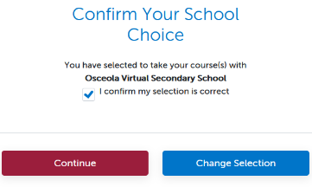
14. Confirm your school choice:

Osceola Virtual High School Course Offerings
Language Arts
English 1 (H)
English 2 (H)
English 3 (H)
English 4 (H)

Mathematics
Algebra 1 (H)
Algebra 2 (H)
Geometry (H)
Liberal Arts Mathematics 1
Math for College Readiness
Pre-Calculus (H)

Science
Anatomy and Physiology (H)
Biology 1 (H)
Earth-Space Science (H)
Marine Science 1 (H)

Social Studies
Economics (H) (S)
United States Government (H) (S)
United States History (H)
World History (H)

Health/Physical Education
Fitness Lifestyle Design (S)
Health Opportunities through Physical Education (HOPE)
Personal Fitness (S)

World Languages
Spanish 1
Spanish 2
Spanish 3 (H)

(H) Honors Available (S) Semester Course

Please check OVS website for more information: ovss.osceolaschools.net

Electives
Career Research & Decision Making (S)
Driver Education/Traffic Safety (S)
Parenting Skills (S)
Peer Counseling 1 (S)
Peer Counseling 2 (S)

Osceola Virtual Middle School
Course Offerings
Language Arts
M/J Language Arts 1
M/J Language Arts 2
M/J Language Arts 3

Mathematics
M/J Mathematics 6
M/J Mathematics 7
M/J Pre-Algebra

Science
M/J Comprehensive Science 1
M/J Comprehensive Science 2
M/J Comprehensive Science 3

Social Studies
M/J World History
M/J Civics
M/J US History

