Save the Date for the Test
9th Graders
PSAT 8/9 – 10/28/2021
10th Graders
PSAT/NMSQT – 10/13/2021
11th Graders
ACT – 10/05/2021
PSAT/NMSQT – 10/13/2021
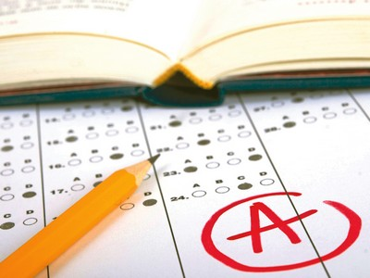
12th Graders
This Photo by Unknown Author is licensed under CC BY-NC-ND
SAT – 10/13/2021
This Photo by Unknown Author is licensed under CC BY-SA-NC

