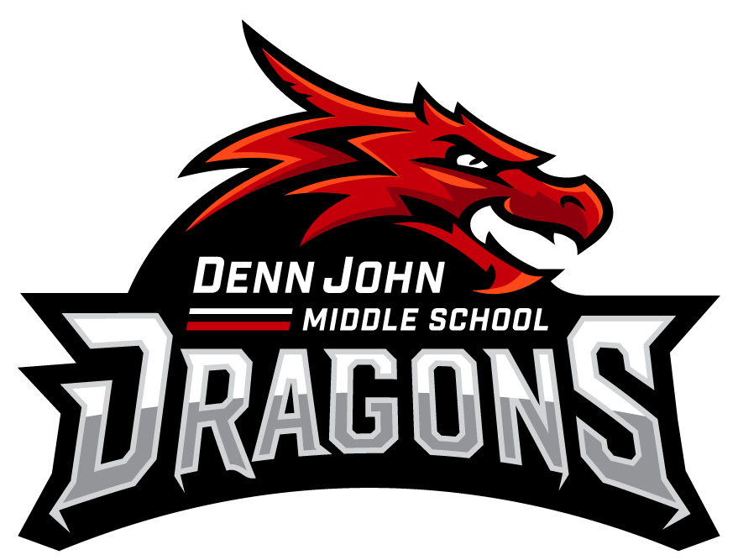

You’re
Invited To Dragon ACademy!

Our DJMS Teachers have been carefully reviewing your Student’s grades and progress and we think they might benefit from some extra help. Please see the options listed on thisand the other attached fliers.
All programs are FREE and offer transportation!

Weekday Mornings
Monday, Tuesday, Thursday and Friday

7:20 – 8:50
Transportation provided
Targeted Intervention for struggling students who may need additional tutoring or remediation opportunities.
Students registered digitally may attend digital remediation.
For the parents or guardians of:
___________________
___________________
PLEASE SCAN EACH FLIER SEPARATELY IF YOU HAVE MULTIPLE INVITATIONS.
Scan the code to sign your student up for Dragon Academy Mornings
OR
Go to:
https://tinyurl.com/y2lyy68t

