New Beginnings Education Center
Media Center Collection Development Plan and Action Plan
October 2022
Written by Patricia Mathews, MLIS

Signatures:

________________________________________ ______________________
Librarian/Media Specialist Date

________________________________________ ______________________
Principal Date

___________________________________ __________________________
School Advisory Chair Date

Purpose Statement:

The purpose of the Collection Development Plan (CDP) is to serve as a guideline for selecting materials that will serve the needs of both students and classroom while supporting curriculum and igniting a love of reading.

Background Statement:

Purpose of the Collection
- The NBEC Library serves the following purposes:
- To build and maintain resources in a variety of formats to support the student learning and the School District of Osceola County (SDOC) curriculum assigned to NBEC.
- To provide quality resources, services, and instruction to cultivate intellectual inquiry and information literacy to the needs of our staff, students, parents, and administrators.
- To aggregate data important to the stakeholders.

Guided by the Marzano Training and iObservation involve the faculty & staff members of NBEC in the collaboration and planning and serving on selected library committees and events as well as the book challenged committee in preparedness of a challenge of library materials and resources.

For a full breakdown of our population, please see below.

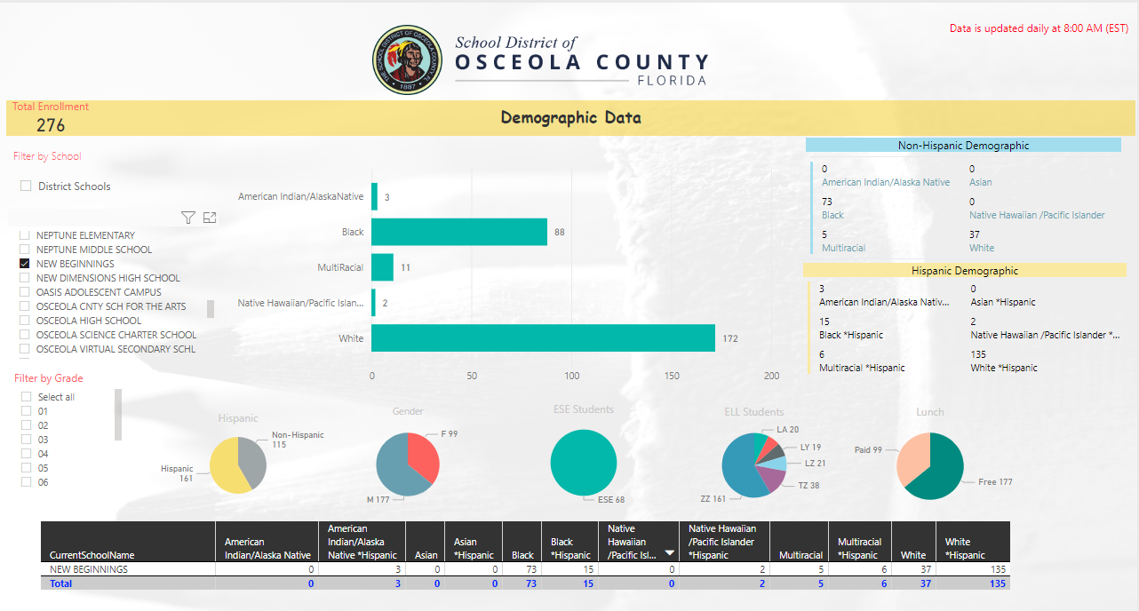

Responsibility for Collection/Development:

The Osceola County School Board holds the final say in media center material acquisition. The certified School Media Specialist will work collaboratively with academic coaches, teachers, and students to identify needs and develop the collection with approval from administration.

School Mission, Vision, and Objectives of Selection:

The Osceola County School Librarians' Association (OCSLA): "The Osceola County School Librarians' Association supports literacy and curriculum through school media programs by promoting collaboration, emphasizing information literacy, technology skills cultivating the love of reading with students, colleagues and our community."

Mission: Inspiring all learners to reach their highest potential as responsible, productive citizens.
Vision: The School District of Osceola County will work in partnership with families and the community to ensure all learners develop the essential knowledge and skills to strengthen our thriving community.

Objectives of Selection: The Osceola County School Board Rule 4.22 (revised on 8/16/22) addresses the objectives of selection:

The primary objective of the school library/media center is to implement, enrich, and support the educational program of the School District and its schools. The school library/media center shall provide a wide range of materials on all levels of difficulty, with diversity of appeal, and the representation of different points of view. For the purpose of this School Board Rule, “educational media materials” in school libraries/media centers shall be defined to include, but shall not be limited to, the following categories: books, periodicals, and other print materials; films; videos; and/or software, etc.

The School Board asserts that the responsibility of the school library/media center is to provide:

A. Instructional and supplemental materials that enrich and support the curriculum, taking into consideration the varied interest, abilities, and maturity levels of the students being served.

B. Materials that stimulate growth in factual knowledge, literary appreciation, aesthetic values, and ethical standards.

C. A background of information enabling students to make intelligent judgments in their daily life.

D. Materials on opposing sides of controversial issues in order that students may develop, under guidance, the practice of critical analysis of all media.

E. Materials representative of the many religious, ethnic, and cultural groups and their contributions to the heritage and culture of America and the world.

F. A comprehensive collection appropriate for the users of the media center placing principle above personal opinion and reason above prejudice in the selection of materials of the highest quality.

Legal Responsibility for Selection: The School Board is legally responsible for all matters relating to the operation of the School District of Osceola County. The responsibility for the selection of educational media materials, regardless of whether the book is purchased, donated, or otherwise made available to students is delegated to a school district employee who holds a valid educational media specialist certificate. School principals are responsible for overseeing compliance with School District procedures for selecting school library media center materials.

Parental Responsibility: Parents shall have the right to review materials in the media center and to request that it be noted in the student’s library record that the student not be allowed to check out certain material.

Criteria for Selection of Educational Media Materials:
A. The standards to determine the propriety of the educational media materials shall be pursuant to Florida Statutes 847.001 and 847.002.

B. Educational media materials shall be evaluated and selected to implement, enrich, and support the educational programs of the School District and its schools. Materials placed in school library/ media center collections shall meet the criteria set forth in the School Board policy.

C. The content of the School District’s approved curriculum shall determine the need for the use of educational media materials.

D. First consideration shall be given to the needs of the individual school based upon knowledge of the curriculum, of the existing collection, and of the needs of children and youth. Requests from users of the collection, (i.e., administrators, faculty, parents, and students) shall be given high priority.

E. Materials shall be considered on the basis of accuracy of content, overall purpose, timeliness, importance of the subject matter, quality of the writing/production, readability and popular appeal, authoritativeness, comprehensiveness of material, reputation of the publisher/producer, reputation and significance of the author/artist/composer/producer, format and price.

F. In determining the suitability and value of the material included in the collection, consideration of the following elements must be given:

- Religion – Material shall be factual, unbiased, and shall represent all major
religions.

2. Ideologies/Philosophies – Material shall contain factual information on any ideology or philosophy that exerts a strong force in society.

3. Sex Education – Material shall be factual information that is appropriate for the age group and/ or related to the school curriculum.

4. Sex – Pornographic, sensational, or titillating materials shall not be included.

5. Profanity – The fact that limited profanity appears in material shall not automatically disqualify a selection. However, care shall be taken to exclude materials using profanity in a lewd or detrimental manner and not in context with the material.

6. Science – Material shall be factual information about medical and scientific knowledge, without any biased selection of facts.

Procedures for Selection of Educational Media Materials: In selecting materials made available to students through the school library/media center, the school media specialist shall:

A. Consult with reputable, unbiased, professionally recognized reviewing periodicals and school community stakeholders (including, instructional media employees, curriculum consultants, faculty, parents, and community members).

B. Require that educational media materials selections meet the criteria set forth in Section 1006.40(3)(d), Florida Statutes.

C. Ensure school library/media center collections shall:

1. Be based on reader interest.

2. Support state academic standards and aligned curriculum.

3. Support the academic needs of students and faculty.

D. Comply with the following procedures when considering materials to be purchased:

1. Purchase materials which are outstanding and frequently used.
2. Periodically replace worn or missing basic items.
3. Withdraw out-of-date or unnecessary items from the collection or items required to be removed pursuant to this policy and applicable state law; and replaced by new and age-appropriate materials.
4. Purchase materials in many types of formats: digital, e-books, electronically, paperback, or hardcover.
5. Examine sets of materials and materials acquired by subscription and purchase only materials that fill a definite need.

E. All School District schools must publish on their school website, a list of all materials maintained in the school library/media center or required as a part of a school-level or grade-level reading list.

Selection Aides: Selection aids include, but are not limited to the following resources:
A. School Library Journal
B. Booklist
C. Book Links
D. Publisher’s Weekly Children’s Books Reviews
E. Horn Book
F. ALA awards lists
G. B.E.S.T. Books
H. Kirkus Reviews
I. Jobbers such as Follett reps, Children’s Plus, and Mackin

Challenge Process for Educational Media Materials: Educational media materials deemed by some individuals to be objectionable may be considered by others to have sound educational value. Any concerned parent, Osceola County resident, or employee of the School District may request reconsideration of educational media materials in a school library/media center.

The following challenge procedure shall be followed:

A. The school media specialist shall discuss the matter informally with the complainant explaining the selection procedures for school library/media center materials. If the complainant accepts the explanation given by the school media specialist, then the reconsideration process concludes.

B. If the explanation fails to resolve the objection, the school principal shall ask the complainant initiating the challenge to file, within two (2) weeks, a formal written objection by completing a “Request for Reconsideration of Library Media” form which must reflect that the complainant has read the material in full. Failure to do so results in the conclusion of the reconsideration process.

C. Media Center Advisory Committee

1. Upon receipt of the completed form "Request for Reconsideration of Library Media," the school principal shall forward copies of the form to the appropriate employees on the school-level Media Center Advisory Committee (e.g., a committee of teachers, educational media specialists, and parents of the school).

2. Pending a final decision, the challenged educational media material:

• shall not be available for student use; but

• shall not be removed from the school library/ media center collection.

3. The Media Center Advisory Committee shall:

• review and consider the objections being raised;

• read and re-evaluate the challenged educational media material; and report its decision within fifteen (15) working days.

4. The school principal shall inform the complainant in writing concerning the Media Center Advisory Committee’s decision.

D. If the complainant disagrees with the decision rendered by the school-level Media Center Advisory Committee, an Appeal may be filed with the School District Educational Media Materials Review Committee.

E. The Superintendent shall appoint a School District Educational Media Materials Review Committee with the following composition:

1. One (1) representative of the Osceola County Public Library Board;

2. One (1) representative of the general public at large;

3. One (1) representative of a school parent organization;

4. One (1) principal from the level at which the complaint originated (K-5, 6-8, or 9-12);

5. Three (3) school-level instructional employees, including the following:

a. One (1) certified media specialist from the level at which the complaint originated;

b. One (1) certified media specialist from another level; and

c. One (1) classroom teacher from the level at which the complaint originated.

6. Two (2) School District-level instructional employees, including the following:

a. One (1) School District-level instructional employee from the level where the material is in question; and

b. The Director of Media and Instructional Technology or designee.

F. The School District Review Committee, in carrying out its assigned function, shall:

1. Read, view, or listen to the educational media material in its entirety;

2. Check general acceptance of the educational media material by reading reviews and consulting recommended lists;

3. Determine the extent to which the educational media material supports the curriculum;

4. Complete the "Checklist for Reconsideration of Library Media," judging the educational media material for its strength and value as a whole and not in part; and

5. Forward, within fifteen (15) working days, a written recommendation to the Superintendent.

G. The Superintendent’s designee shall inform the complainant and the school media specialist of the School District Review Committee’s decision to retain or withdraw the challenged educational media material.

H. Appeal to Superintendent
1. If the complainant or the school’s media specialist is dissatisfied with the School District Review Committee’s decision, a written appeal may be filed with the Superintendent.

2. Failure of the complainant to file a written appeal within thirty (30) days of the School District Review Committee’s decision shall result in a conclusion of the reconsideration process, and the decision of the School District Review Committee shall be final.

3. The Superintendent shall, within thirty (30) days of receipt of the appeal, send the complainant and the school media specialist a written decision.

I. Appeal to the School Board
1. If the complainant or the school’s media specialist is dissatisfied with the Superintendent’s decision, a written appeal may be filed with the School Board.

2. An appeal to the School Board of the Superintendent’s decision must be filed within ten (10) days after the Superintendent’s decision.

3. Failure of the complainant to file a written appeal within ten (10) days after the Superintendent’s decision shall result in a conclusion of the reconsideration process, and the decision of the Superintendent shall be final.

J. The School Board shall consider the decision of the School District Review Committee, the decision of the Superintendent, and any other appropriate documentation (e.g., meeting summaries, material reviews, etc.). The decision of the School Board regarding appropriateness of a particular school library/media center material item shall be considered final.

K. School library/ media center materials in question, can only be removed from circulation and/ or used in the School District through the procedures of this policy.

Loan of School District Educational Media Materials: A. Educational media materials owned by the School Board are not normally made available to non-school-related groups.

Under exceptional circumstances, the Superintendent or designee may approve for loan educational media materials and equipment from a school or the Professional Development Center.

No charge is normally made for the occasional use of educational media materials. However, the borrowing group shall be responsible for any damage occurring during the use of the borrowed educational media materials.

Target Audience:

Elementary, Middle and High School teachers, students, and support staff.
Budgeting and Funding:
Schools in Osceola County typically receive funding from the district/state. This year, half of the budget was available in July and the other half will be available in January.
When the budget strip is released, the money will be spent by the deadline. None of this money can be used to purchase technology. It must be used for instructional materials including print books, eBooks, journals, electronic resources, and databases. For any concerns or questions about a material, contact Pam Fordham at the district office. Other Media Center funding is supplemented with a fundraiser. Typically, that entails a for-profit book fair and other fundraising opportunities as needs arise.

Collection Analysis:

According to a Titlewave Analysis through Follett, the below information shows our collection as of September 2022 (see below).

For E-books, we use Follett shelf built into the catalog and Mackin Via (these are not included in the below collection analysis report).
For print books, any book added to the collection should be hardcover whenever available (Kapco Covers are used if only paperbacks are available through other vendors). Paperbacks permitted for group/class sets, recorded book pairings, professional materials also permitted in paperback. Items may be ordered through any approved vendor.

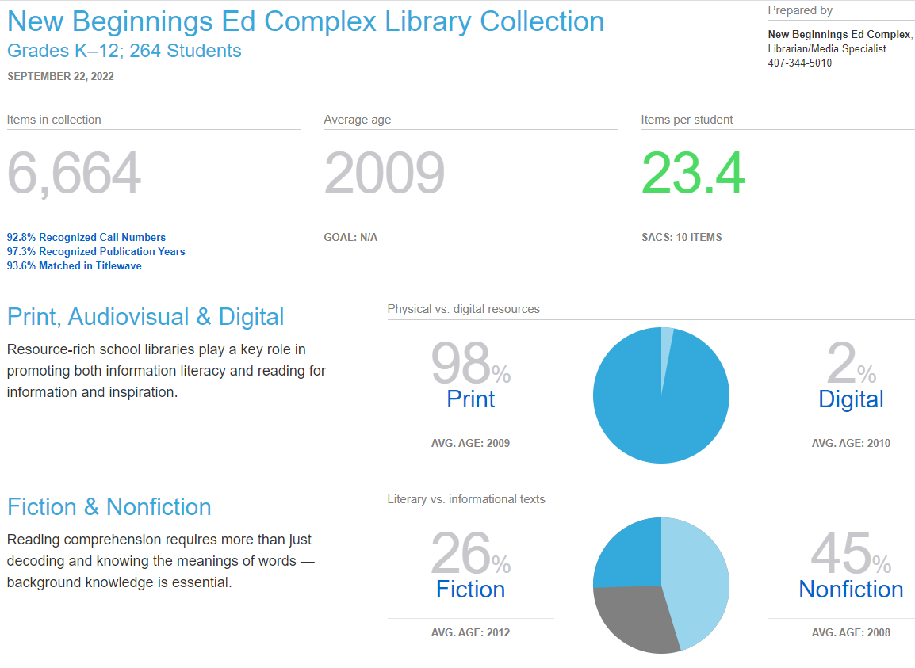

Intellectual Freedom:
We stand with ALA on Intellectual freedom that, “ALA actively advocates in defense of the rights of library users to read, seek information, and speak freely as guaranteed by the First Amendment. A publicly supported library provides free and equal access to information for all people of that community. We enjoy this basic right in our democratic society. It is a core value of the library profession.”

Weeding:

Weeding and keeping the library collection fresh and up to date
keeps the library collection relevant and useful. Continuous review of library materials will be necessary as a means of maintaining an active collection of current interests of the students, faculty, and staff at NBEC.

Replacements:

Items will be replaced as necessary. If an item is lost or damaged beyond acceptable salvation, the patron may be responsible for the original purchase price as indicated in the Destiny Library System.

Special Collections:

Class sets are continuously evaluated for relevancy, date of publishing, frequency of use, and to see if they align with the B.E.S.T standards.

Gifts:

Gifts of media or books may be accepted at the discretion of the Media Specialist with the understanding that their use or disposition shall be determined, according to the same selection criteria and procedures as purchased materials.

Action Plan based on Collection Development Policy:

The library/media center will be a safe place open to all students, staff, and parents to meet, work, and collaborate. We will have seating areas, collaborative spaces, and furniture conducive to this end.

A regular weeding schedule will be instituted next year after a major deselection of library materials has been conducted. The current collection is grossly outdated, and efforts are being made to update the collection.

Weed and replace outdated books in:

2022-2023 Fiction

Continue to Weed and Replace outdated books in the following sections:

2023-2024 Easy, 000s, 100s, 200s, 300s and 600s
2024-2025 Biography. 800s and 900s
2025-2026 Reference, 400s, 500s and 700s

Every effort is made to have a well-rounded, authoritative collection in the subject areas covered by the State of Florida and the School District of Osceola County (SDOC).

Attachment #1

New Beginnings Education Center
Media Advisory Committee 2022-2023

Ms. Ashley Condo, Principal
Ms. Tatiana Vargas, New Teacher Lead
Ms. Imani Pagan-Ortiz, High School ELA Teacher
Ms. Gayle Murray, K-2 Teacher
Ms. Patricia Mathews, MLIS, Librarian/Media Specialist

