NBEC Counseling information
A message from your Counselor:
While these are trying times for all of us, and as we transition to digital learning, we want to assure you that we are committed to supporting our students with personal/social and academic needs.
I’m available during the office hours listed. I can be reached via Email, Jabber, Bookings, Remind or Teams chat. I encourage everyone to login to Teams and REMIND. Follow the directions and use the codes to join.

.

Students from your office 365 account, click on Microsoft TEAMS, then Click on Join or create a team

Join “teams” using appropriate code
- NBEC Ms. Courtney Senior Class 2020: m5jlka9
- NBEC Ms. Courtney 9th-11th Grades: pjqe0c5
- NBEC Ms. Courtney 6th-8th Grades: gte9iq3
- NBEC Ms. Courtney K-5th Grades: r1repvw
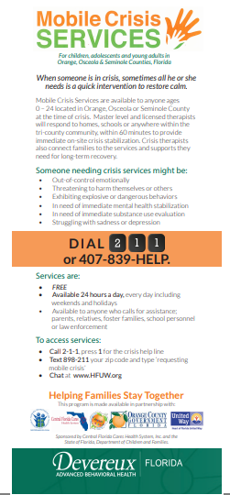

Join “REMIND” using appropriate code
- NBEC Ms. Courtney Senior Class 2020: 8ebe24
- NBEC Ms. Courtney 9th-11th Grades: faf8adk
- NBEC Ms. Courtney 6th-8th Grades: nbecm
- NBEC Ms. Courtney K-5th Grades: dgk96d

Cancellation of State Assessments
Current Seniors:
If a senior is expected to graduate in spring 2020 and has not met the exit criteria for Algebra I EOC and/or Grade 10 ELA FSA, or earned a concordant score, this criterion will be waived. However, students still must earn the necessary credits and meet the GPA requirements to graduate.

