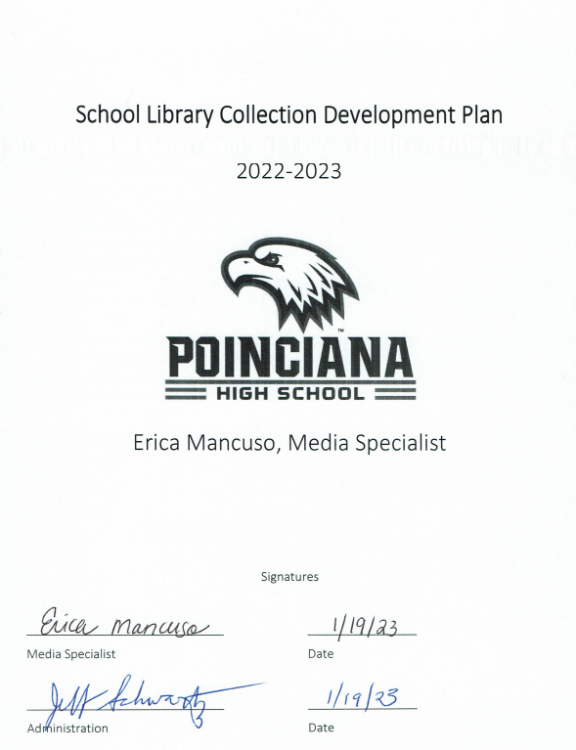

Table of Contents

- Purpose Statement………………………………….….……………………………………………………………………3
- Mission, Goals, Objectives.……………………….….…………………………………………………………………..3
- School Background……………………………………….………………………………………………………………….4
- Target Audience…………………………………………….…………………………………………………………………4
- Responsibility for Selection of Materials..….……………………………………………………………………..5
- Criteria for Selection of Materials..…………….…………………………………………………………………….5
- Budget and Funding.……………………………………………………………………………………………….……….5
- Collection Analysis .……………………………….……………………………………………………………….…….6-7
- Weeding..………………………………………………….……………………………………………………………………..8
- Gifts and Donations..………………………………….…………………………………………………………………….8
- Replacements.…………………………………………….…………………………………………………………….……..8
- Special Collections.…………………………………….…………………………………………………………………….8
- Challenge to Instructional and Library Material.….……………………………………………………..……8
- Intellectual Freedom……………………………………….…….………………………………………………….……..9
- American Library Association Bill of Rights……….….…………………………………………………….…….9
- Three-Year Action Plan…………………………………….…………………………………………………………….10

Purpose Statement:
The purpose of the Media Center is to enrich and support the students, staff, and educational program of the school. This plan will provide the framework for the selection of materials needed to serve the needs of both students and classrooms while supporting curriculum.

Mission, Goals, and Objectives:

Osceola County Mission
“Inspiring all learners to reach their highest potential as responsible, productive citizens.”

Osceola County School Librarians' Association Mission
“The Osceola County School Librarians' Association is committed to supporting literacy and instructional curriculum through school media programs in Osceola County by promoting collaboration among colleagues, emphasizing information literacy instruction and 21st century technology skills, and sharing the love of reading with students, colleagues and community members.”

Poinciana High School Mission
“Engaging all stakeholders in respectful communication and productive collaboration for post-secondary success.”
The goal of the Poinciana High School Media Center is to foster lifelong reading habits for academic, career, leisure, and personal interests.

In order to achieve schoolwide goals, the Media Specialist will:
- provide resources to meet the educational needs of all students.
- select resources in a variety of genres, from multiple perspectives, and in appropriate formats.
- select, without bias, using predetermined criteria from the Collection Development Policy.
- offer a broad selection of material to young people as they form their tastes and opinions.
School Background:
Poinciana High School is a Title 1 school and currently serves a diverse population of about 2,400 students in grades 9-12 (see below for specific demographic data). There are a variety of vocational, college preparation, performing arts, clubs, professional organizations, and sports/athletic programs offered. The Career and Technical Education Programs offered include: Navy ROTC, construction, automotive repair, culinary, nursing, computer science, and digital design. The Osceola Business Academy and Entrepreneurship program hosts a branch of Addition Financial on campus. Poinciana High School is an AVID National Demonstration School and offers the ASCEND Program to prepare students for acceptance into the Top 100 Universities in the United States.
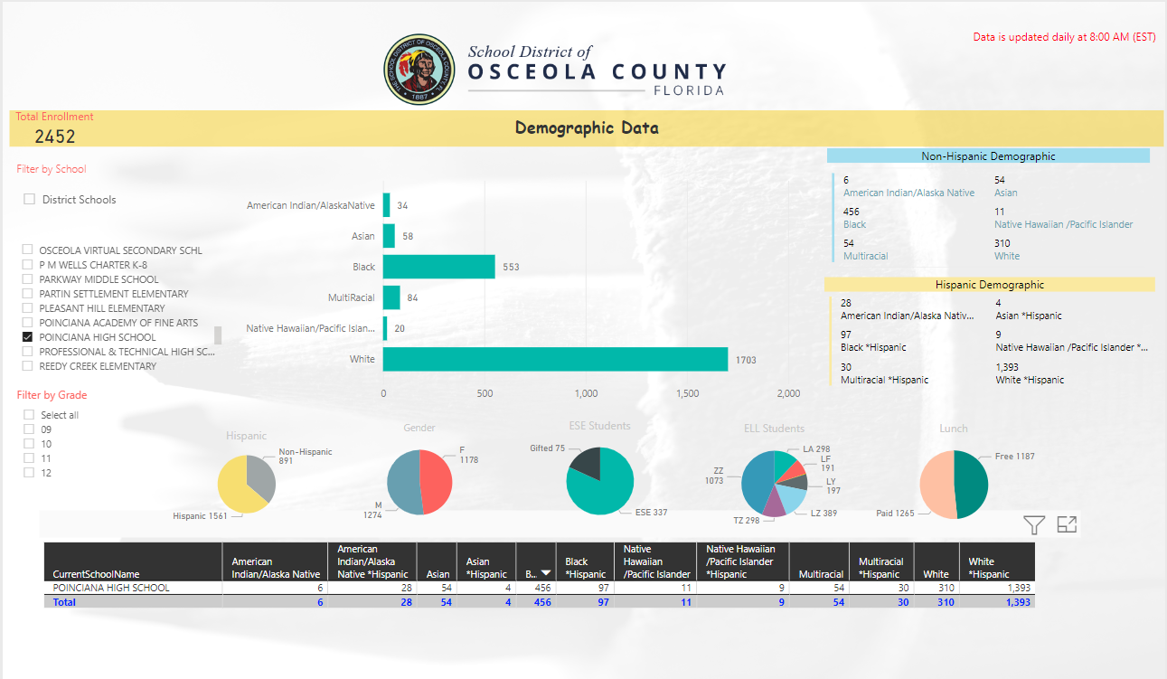

Target Audience:
Students, teachers, support staff, and stakeholders.

Responsibility for Selection of Materials:
The Board Members of the School District of Osceola County School hold the final decision in Media Center material purchasing. A certified media specialist will be appointed to work collaboratively with school personnel (e.g., principals, teachers, academic coaches, other media specialists), students and parents to identify needs and develop the collection.

Criteria for Selection of Materials:
Requests for purchases may be submitted directly to the media specialist or by filling out a survey on the school website throughout the year. Final decision making for purchases is made by the media specialist. All requests will be considered with the following as a guideline:
- Who made the request? Was it a student request?
- Is the item appropriate for students in grades 9-12?
- Is the material/publish date relevant and/or timely?
- Is it a reliable source?
- Does it support the curriculum and educational goals of the school?
- Does the collection already heavily represent the title/subject?
- Is it readable and visually appealing?
- How many patrons will benefit from item?
- Does it contribute to the diversity of the collection on controversial issues and multicultural awareness?
- Does it have a lasting importance to a field of knowledge?
- Does it support professional development needs of the faculty?
- Is it a popular title/subject/author?
- If the request is for a class set: is there a multiuser eBook available? Does the title have a heavy presence in the district? (If so, utilizing the interlibrary loan system may be more appropriate/cost efficient.)

Budget and Funding:
Schools in Osceola County generally receive funding from the district/state in the Fall of the school year. All purchases are to be approved by the district and typically completed by December. However, this year, purchases will take place after January 3, 2023. Purchases must be for instructional resources such as print books, eBooks, journals, electronic resources, and databases. This funding cannot be used for technology purchases. Additional funding will be obtained through fundraising.

Collection Analysis:
The average age of the collection is 2011 and the breakdown of categories is as follows:
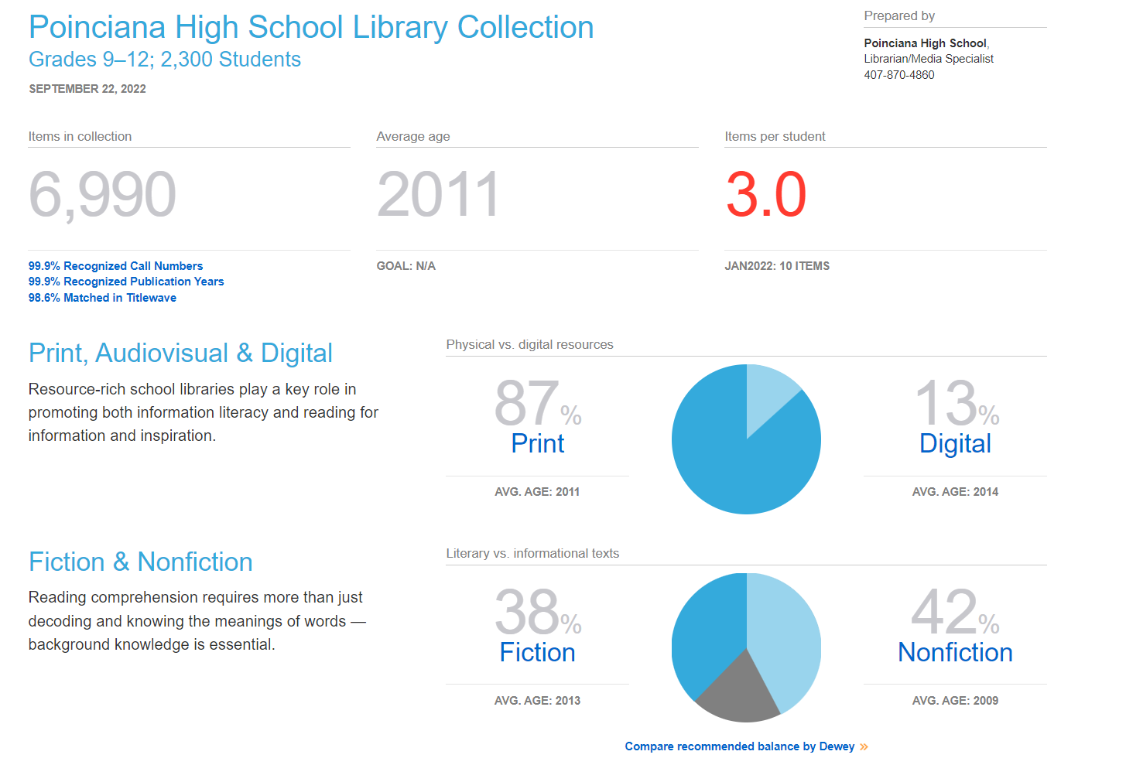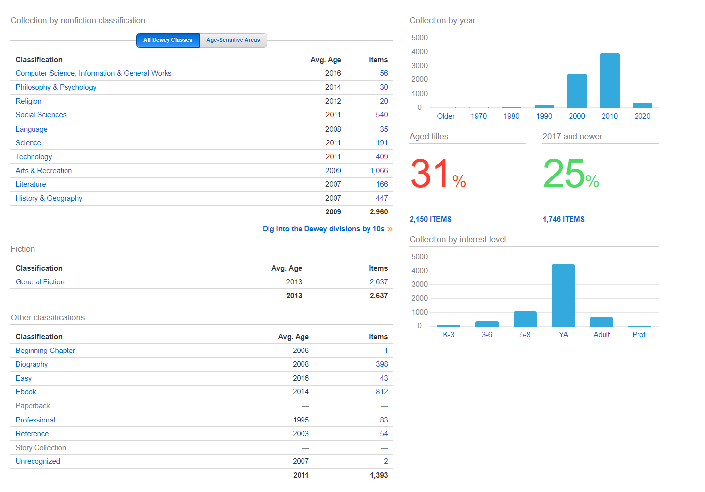
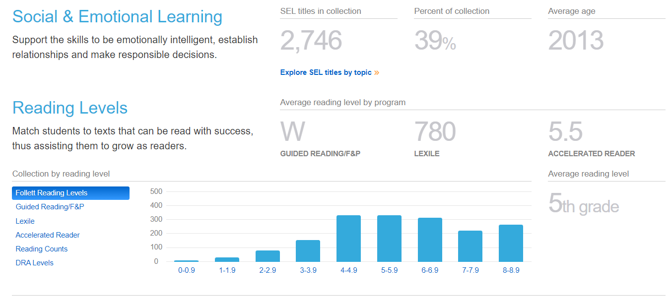

Weeding:
One of the underlying principles of collection development is the evaluation and removal of material in the existing collection that no longer is current or meets the needs of the curriculum. Weeding ensures that the collection contains only those resource materials, which are accurate, current and relevant to the curricular and recreational programs at each school. The final decision on whether to weed an item or not will be determined by the media specialist.
Considerations for removal:
- Worn and damaged titles.
- Material which is no longer in demand, or which no longer supports the curriculum.
- Material which has not circulated in 3 to 5 years.
- Non-circulating duplicates.
- Material that contains outdated, misleading, or trivial information.

Gifts and Donations:
Gift materials must meet the same basic selection criteria used for new materials. Gifts are accepted with the understanding that if unsuitable, they will be disposed of at the discretion of the media specialist. The same selection criteria will be used when purchasing materials with donated monies.

Replacements:
Items will be replaced as necessary. If an item is lost, or damaged beyond acceptable salvation, the patron will be responsible for the original purchase price as indicated in the system.

Special Collections:
The media specialist will work to develop the professional section of the media center to support teachers in professional development. Material should benefit as many teachers as possible, be relevant, and have a current publication date.

Challenge to Instructional and Library Material:
There may be an occasion when a student, teacher, parent, or community member may challenge a book’s relevance to the collection. In the case of such a complaint, the school’s Media Advisory Committee will meet and follow the criteria for reconsideration of library materials. For more information: Challenge Procedures.pdf (osceolaschools.net)
Intellectual Freedom:
We stand with ALA on Intellectual freedom that, “ALA actively advocates in defense of the rights of library users to read, seek information, and speak freely as guaranteed by the First Amendment. A publicly supported library provides free and equal access to information for all people of that community. We enjoy this basic right in our democratic society. It is a core value of the library profession.”
Osceola County School Board Rule 4.30 addresses all instructional materials, including, but not limited to, textbooks, audio-visual materials, digital media, library materials, etc.

American Library Association Bill of Rights:
“The American Library Association affirms that all libraries are forums for information and ideas, and that the following basic policies should guide their services.
- Books and other library resources should be provided for the interest, information and enlightenment of all people of the community the library serves. Materials should not be excluded because of the origin, background, or views of those contributing to their creation.
- Libraries should provide materials and information presenting all points of view on current and historical issues. Materials should not be proscribed or removed because of partisan or doctrinal disapproval.
- Libraries should challenge censorship in the fulfillment of their responsibility to provide information and enlightenment.
- Libraries should cooperate with all persons and groups concerned with resisting abridgment of free expression and free access to ideas.
- A person’s right to use a library should not be denied or abridged because of origin, age, background, or views.
- Libraries which make exhibit spaces and meeting rooms available to the public they serve should make such facilities available on an equitable basis, regardless of the beliefs or affiliations of individuals or groups requesting their use.

Adopted June 19, 1939, by the ALA Council; amended October 14, 1944; June 18, 1948; February 2, 1961; June 27, 1967; January 23, 1980; inclusion of “age” reaffirmed January 23, 1996.”

Three-Year Action Plan:
This action plan covers the School Year 2022-2023, 2023-2024, and 2024-2025.

Year One – 2022-2023 Weed and replace outdated nonfiction in Dewey 900s (History & Geography) and 800s (Literature). Purchase new fiction books following guidelines previously mentioned. Increase book selections in high interest areas (e.g., graphic novels/manga).

Year Two – 2023-2024 Weed and replace outdated nonfiction in Dewey 700s (Arts & Recreation) and 400s (Language). Increase selection of fiction, eBooks, and high interest areas. Consider electronic replacements where appropriate.

Year Three – 2024-2025 Weed and replace outdated nonfiction in Dewey 600s (Technology) and 300s (Social Science). Increase selection of fiction, eBooks, and high interest areas. Consider electronic replacements where appropriate.

Every Year – Subscriptions to databases and eBooks (all formats: audiobooks, videos, eBooks, etc.) Review and replace outdated college, career, and professional resources as needed.

