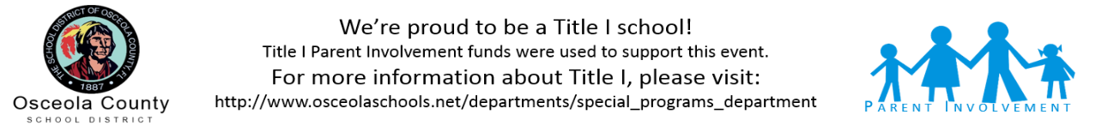

Come out and learn about our Title I Program and School Improvement Plan goals and strategies. You will learn about your right to be involved with school decisions, family involvement events, and the curriculum and assessment of your student.

Food and other refreshments will be served. Spanish translation services will be available.

2300 S Poinciana Blvd., Kissimmee

Jeff Schwartz 407-870-4860

Title I Annual Meeting and SAC School Improvement Plan Approval

OBA Mixer Space

September 16, 2024

6:00PM

Poinciana High School