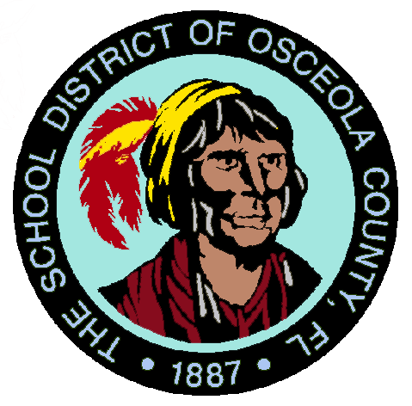

##### ****THE SCHOOL DISTRICT OF OSCEOLA COUNTY, FLORIDA****

***Liberty High School***

##### **4250 Pleasant Hill Rd. 🞄 Kissimmee🞄 Florida 34746**

PHONE: (407) 933-3910 • FAX: (407) 933-9990 • www.lbhs.osceolaschools.net

**Principal**

DR. LA TONIA HARRIS

**Assistant Principals**

STEVEN LOUIS JEAN

DAVID EDWARDS

SHAQUANA MORGAN

DR. CINDY RAMDIAL-BUDHAI

**School Board Members**

Teresa “Terry” Castillo

Chair

District 1 – Kissimmee

407-577-5022

Julius Melendez

District 2 - Kissimmee

321-442-2862

Jon Arguello

District 3 – Kissimmee

407-433-9082

Heather Kahoun

District 4 – Kissimmee

407-870-4009

Erika Booth

Vice-Chair

District 5 – St. Cloud

407-460-1370

Agenda

School Advisory Council

Thursday, March 9, 2023  
6:00pm

Liberty High School PD Room

* Introduction and Welcome
  + - Special Guest – District 3 School Board Member, Jon Arguello
* Mission Statements
* Reading/Adoption of February 2023 Minutes
  + - Vote Required
* SAC Budget Update
  + - Treasurers Report
    - Fund Requests - 1 Request from Ms. Morgan…
      * Vote Required
* Principal’s Report
* Old Business
* New Business
  + - School Improvement Plan Mid-Year Updates by Mr. Louis-Jean
    - Addition of New Members – Vote Required
    - Proposal of New Amendment of LHS Bylaws – Vote Required
* Public Open Comment

**Next Meeting**

**Thursday, April 13, 2023**

**6:00pm**

**Mission Statement**

*Liberty High School will ensure every student is successful in a safe and secure environment while acquiring the necessary social and academic skills needed to be lifelong learners, as well as competent and responsible citizens.*

**Superintendent of Schools**

**Dr. Debra Pace**

